PHILOSOPHY

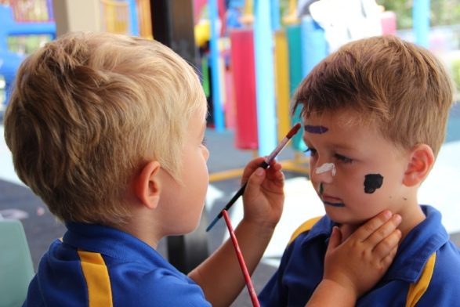
At Peregian Beach College Early Learning Centre we provide the children in our care with play-based experiences which are linked to an intentional teaching and learning program. Our Educators aim to guide, scaffold and support children’s learning; making the most of every teachable moment whilst nurturing the children’s natural curiosity and inspiring enquiry. We educate the children in our care drawing upon evidence-based practices, guiding documentation and research based on Early Childhood development.

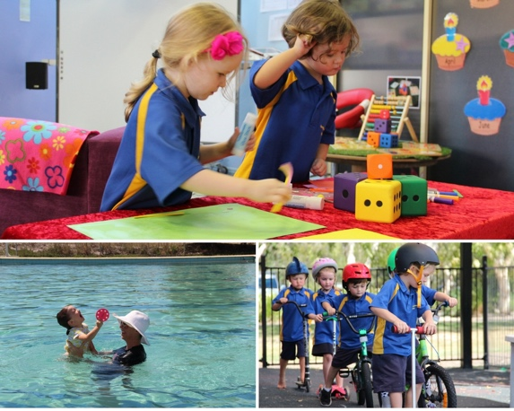
We are set apart from other long day care / Kindergarten facilities as we were established specifically to provide early learning spaces for 3 to 5 year olds to attend and access the ‘flavour’ of our beautiful College. We have the luxury of access to the College by means of Specialist Teachers and facilities for Music, Bushkindy, Library and Splash sessions (in the College pool). We link closely with the school community joining in various activities and events.

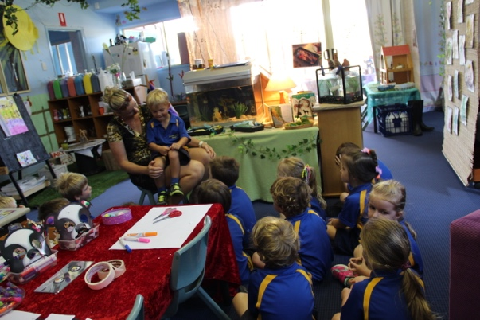
Our 2-weekly planning cycle is transparent, as the children, their families and the staff are all intrinsically and authentically part of the planning process. Each child is given regular opportunities to make decisions about how the next session, the next day, or the next few weeks might look like, feel like, or how it may evolve. We very carefully balance our scope and sequence of learning intentions between explicit teaching moments and emergent uninterrupted play periods.

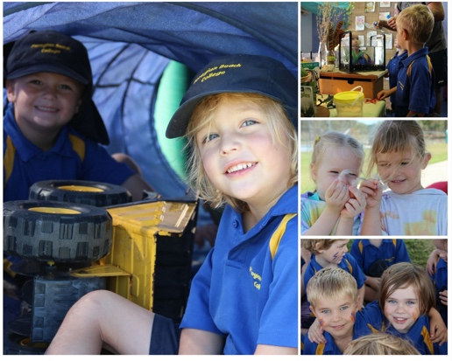
We value our families and we welcome open and honest communication with them regarding their child’s care and education. We encourage feedback from our families and we seek out the wealth of skills, expertise and knowledge that they possess, in order to enhance and increase the children’s quality of experiences. We record children’s growth, interests and development daily. We provide regular, relevant feedback to families about their children’s progress, in a unique and distinctive way.

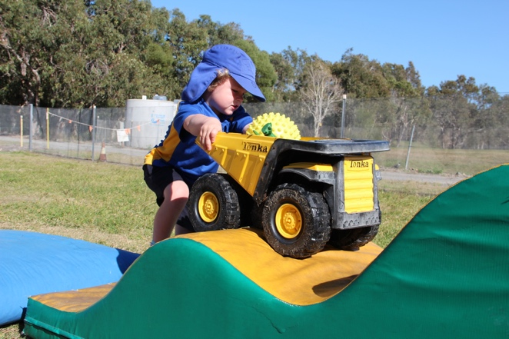
We deliberately set up our indoor and outdoor learning environments, with the purpose of making the whole facility feel ‘exciting and inviting’. These play areas collectively cater for aspects including; individual learning styles, the interests of the children, curriculum outcomes, teacher/specialists’ creative ideas, our community values and the identified developmental needs and strengths of each child.

We at Peregian Beach College Early Learning Centre are ‘Teachers who love to teach’, creating ‘children who love to learn’. Our staff are professional, highly experienced, collegial team members. We pride ourselves on our unique connection with each other and the connection that we are able to enjoy and experience with our Kindy families and our wider school community. We are a not for profit organisation; we educate and care for the children in our service because we love attending our Centre each day in the privileged role of impacting young lives, for life!

